**Required Figures for Lab Reports**

**Limnology (E455/556)**

**Fall 2020**

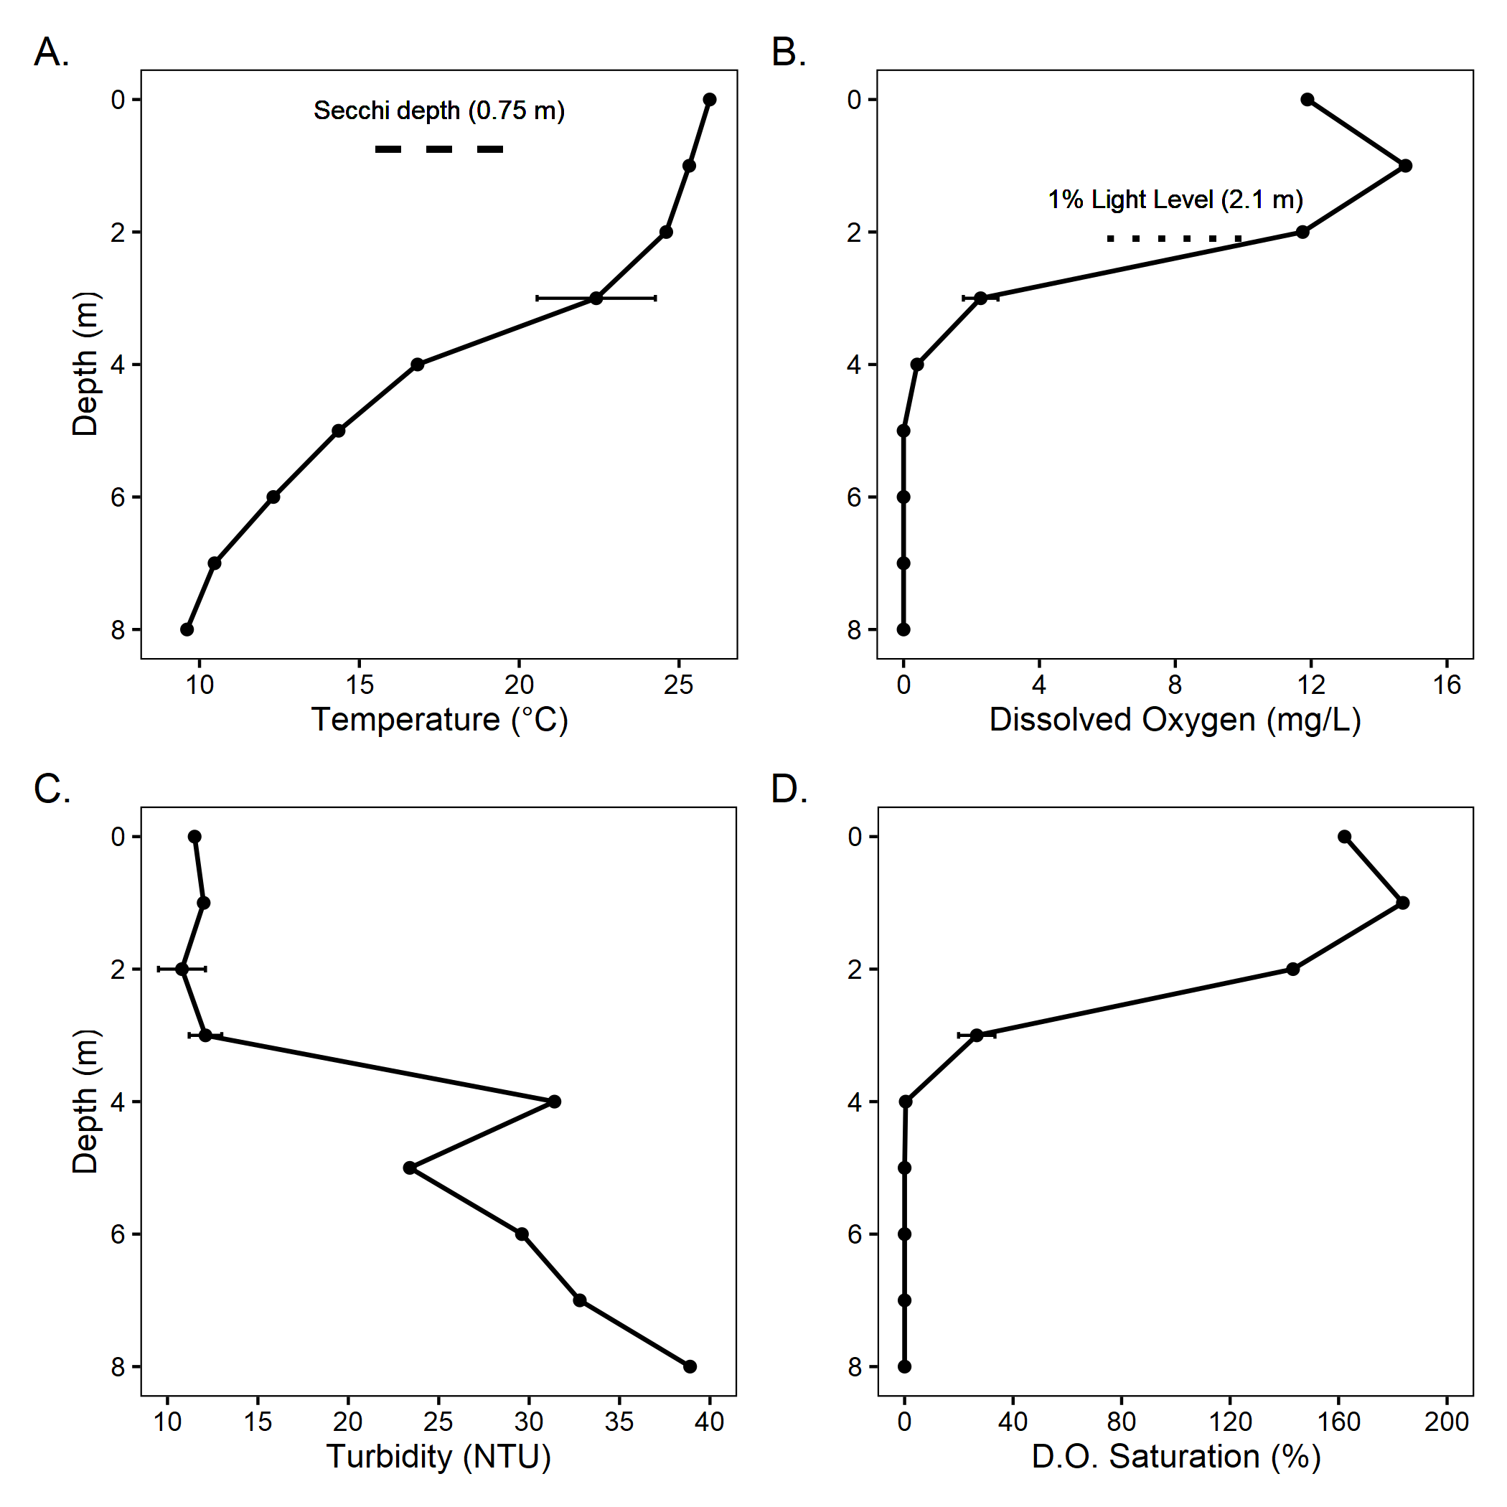

Figure 1 – Vertical profiles for **(A.)** temperature, **(B.)** dissolved oxygen, **(C.)** turbidity, and **(D.)** percent saturation of dissolved oxygen from University Lake, IN. Data were collected on 10/26/17 and 10/27/17. Error bars indicate deviation of replicates (2 m) and duplicates (3 m).

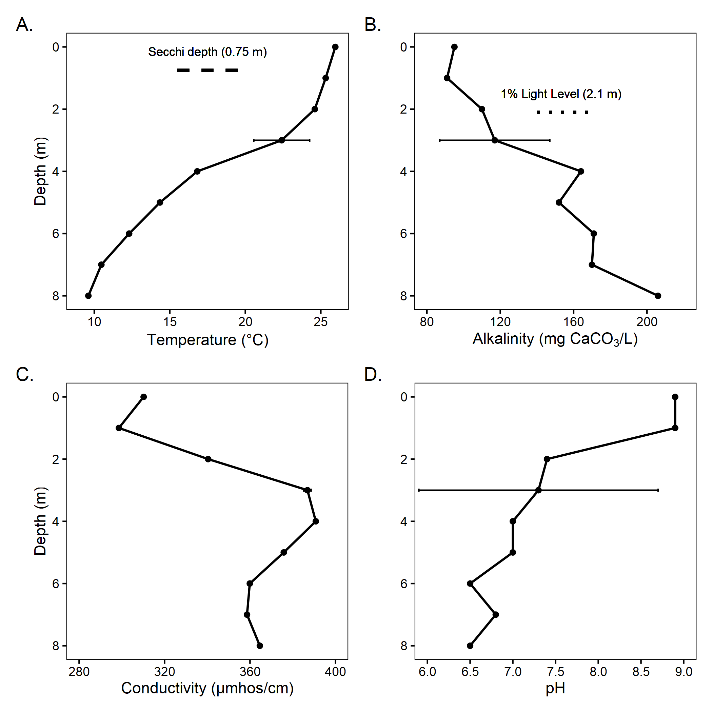

Figure 2 – Vertical profiles for **(A.)** temperature, **(B.)** alkalinity, **(C.)** conductivity, **and (D.)** pH from University Lake, IN. Data were collected on 10/26/17 and 10/27/17. Error bars indicate deviation of replicates (2 m) and duplicates (3 m).

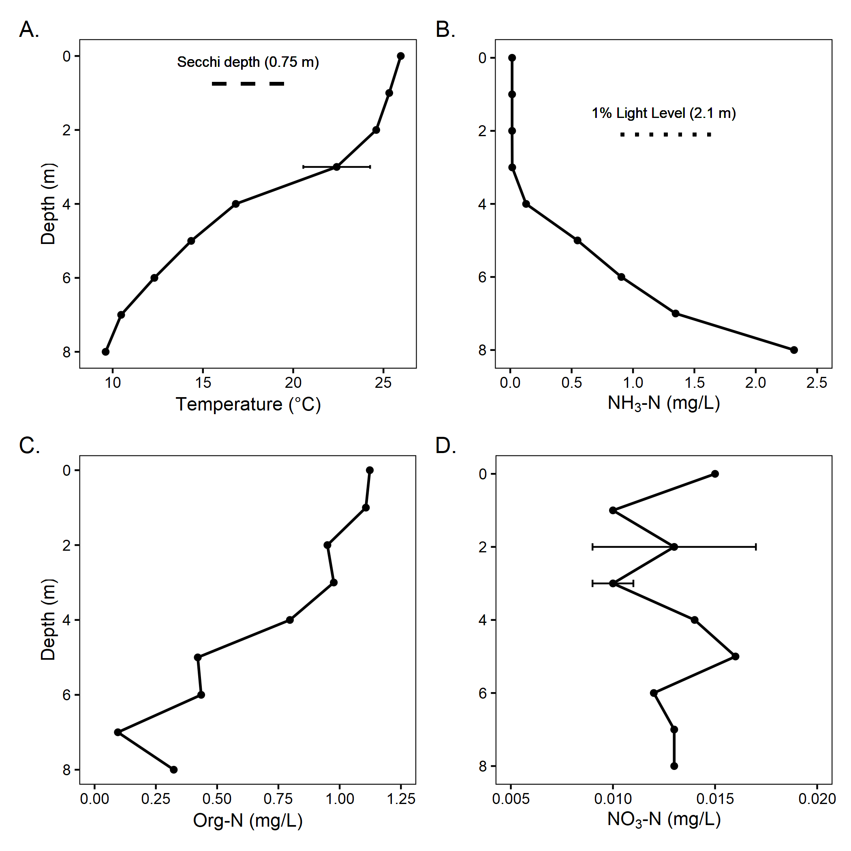

Figure 3 – Vertical profiles for **(A.)** temperature, **(B.)** ammonia (NH3-N), **(C.)** organic nitrogen (Org-N), and **(D.)** nitrate (NO3-N) from University Lake, IN. Data were collected on 10/26/17 and 10/27/17.

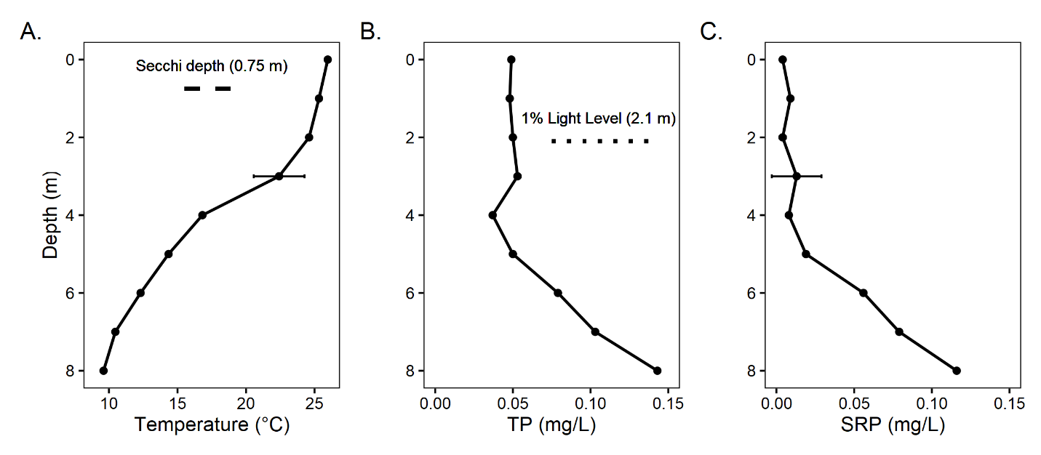

Figure 4 – Vertical profiles for **(A.)** temperature, **(B.)** total phosphorus, and **(C.)** soluble reactive phosphorus from University Lake, IN. Data were collected on 10/26/17 and 10/27/17.

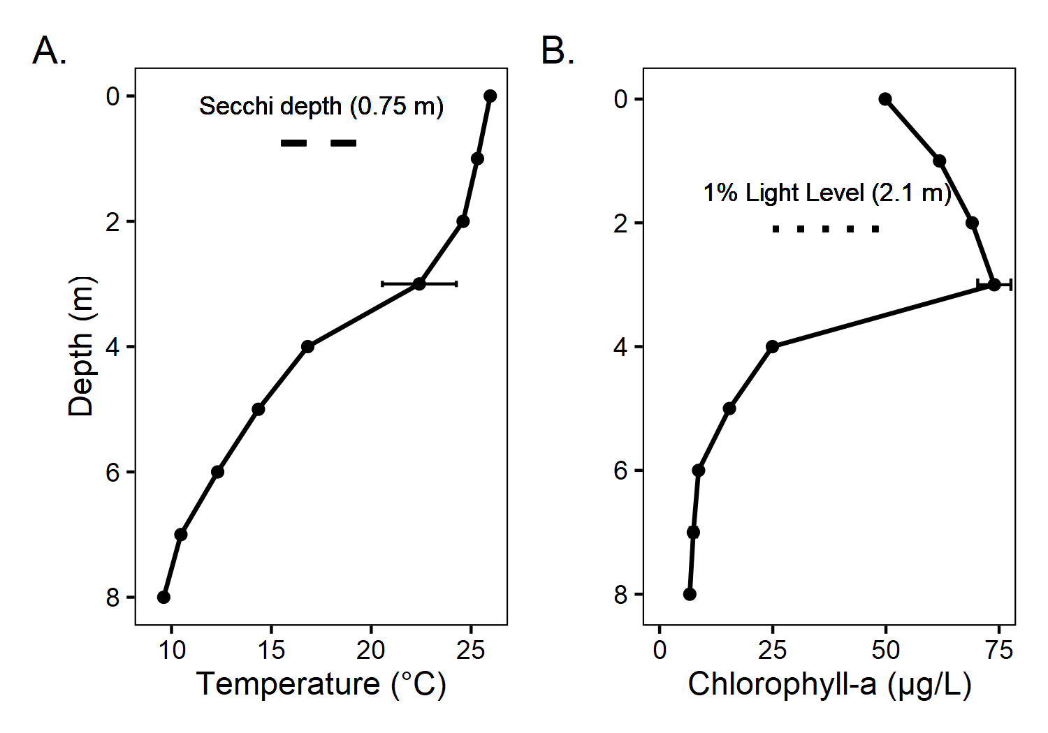

Figure 5 – Vertical profiles for **(A.)** temperature and **(B.)** chlorophyll-a from University Lake, IN. Data were collected on 10/26/17 and 10/27/17. Error bars indicate deviation of replicates (2 m) and duplicates (3 m).

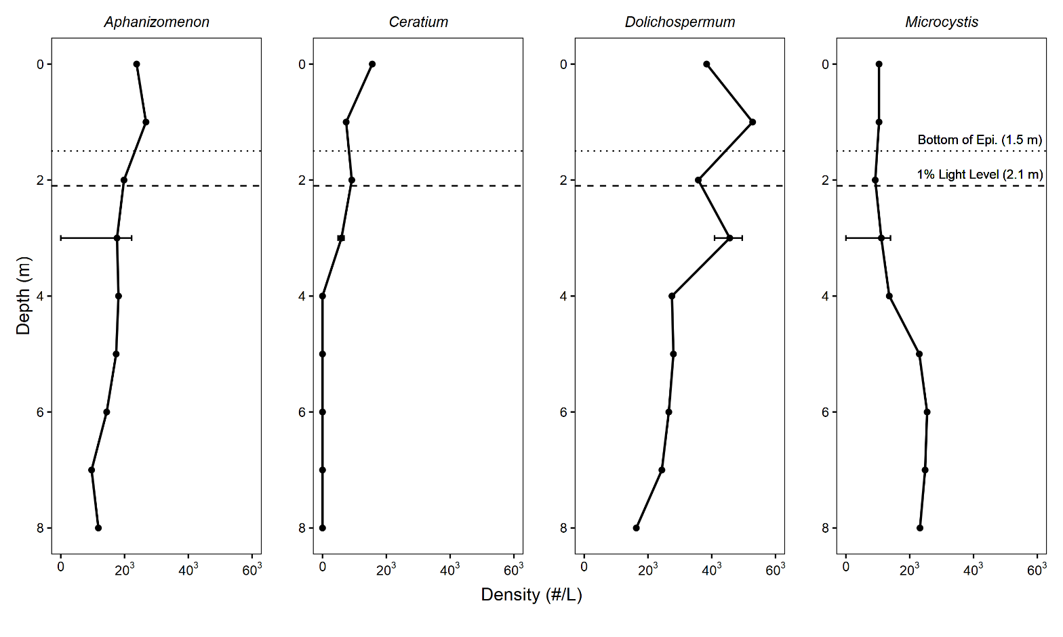Figure 6 – Vertical profiles for phytoplankton from University Lake, IN. Data were collected on 10/26/17 and 10/27/17. Error bars indicate deviation of duplicates (3 m).

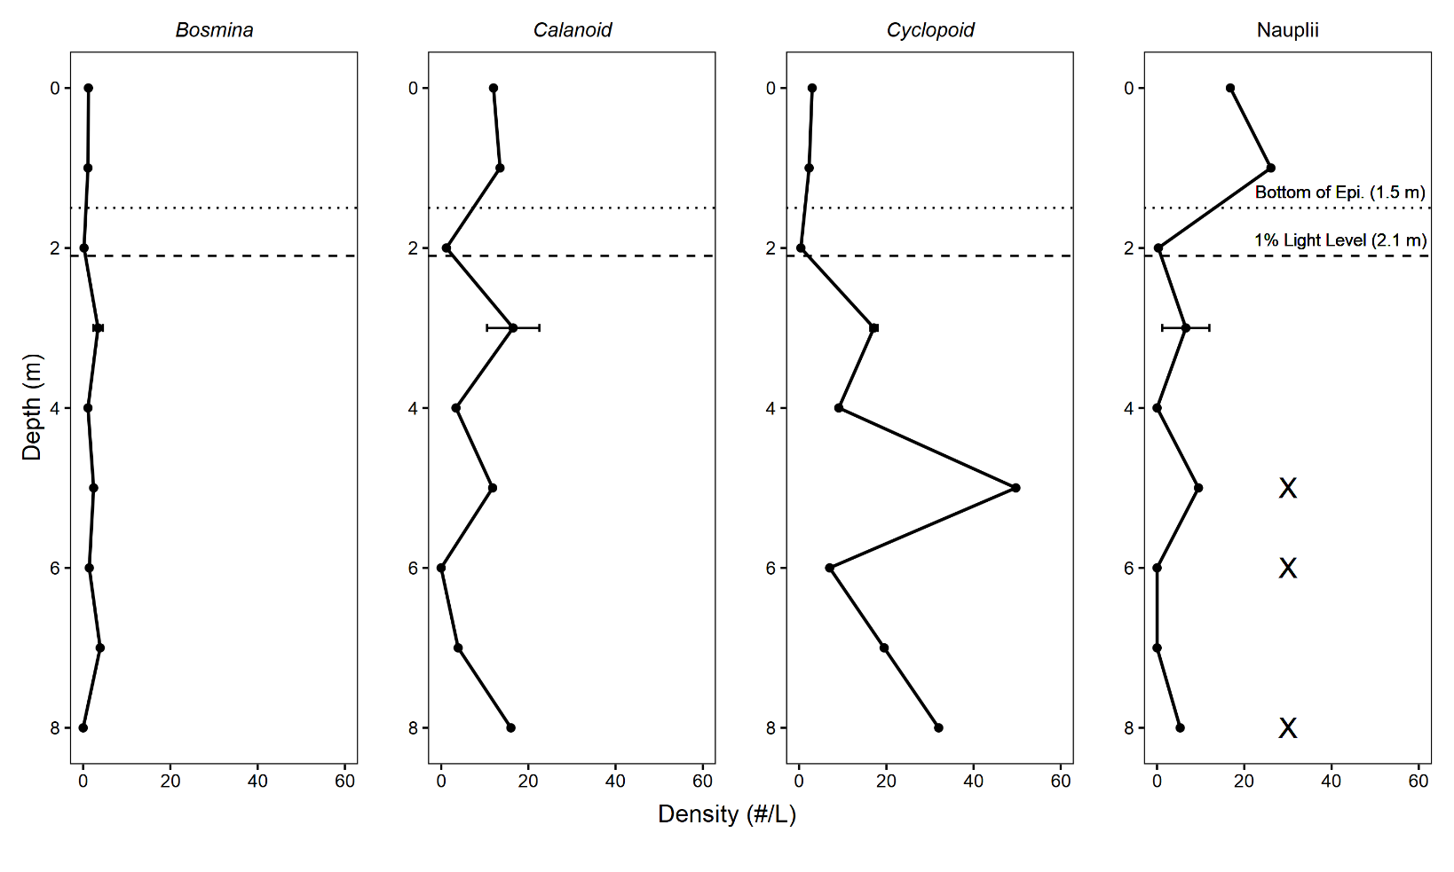

Figure 7 – Vertical profiles for zooplankton from University Lake, IN. Data were collected on 10/26/17 and 10/27/17. Error bars indicate deviation of duplicates (3 m). The presence of *Chaoborus* is indicated with an **X**.

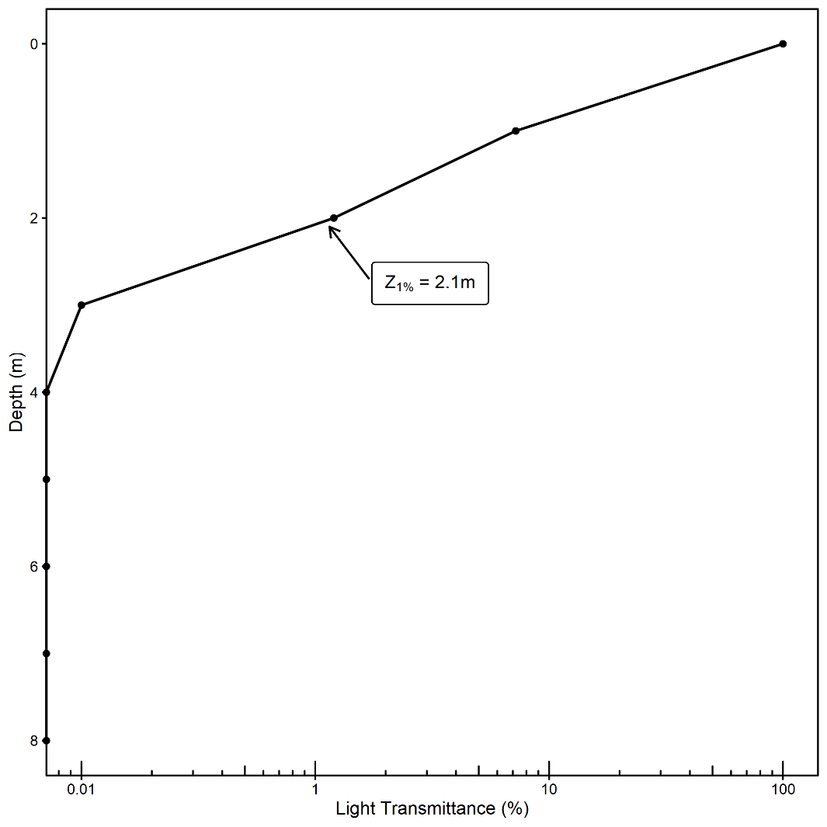

Figure 8 – Light transmission from University Lake, IN. Data were collected on 10/26/17 and 10/27/17.